Notification Engine Assessment Report

Executive Summary 3
1 Assumptions 4
2 Solution Overview 5
2.1 Problem Statement 5
2.2 Requirements and Scope 7
2.3 Non-Functional Requirements 8
2.4 Constraints 9
2.5 Out of Scope 9
3 Platform Assessment 10
3.1 How the platforms were assessed 10
3.2 Leaders Selection 10
3.3 What each platform provides 11
3.4 Platform highlights 12
3.5 Measured against requirements 15
4 Integration with the Existing Landscape 18
4.1 Where the platform sits 18
5 Concerns 20

Executive Summary
Project objective | To identify a notification engine (CPaaS) that can deliver operational notifications to Jewson customers by push, SMS and email, and to describe how it would fit into STARK UK's existing landscape, so that an engine can be chosen with a clear view of its strengths, limitations and conditions.

Project brief | Jewson customers depend on timely information about their orders and trade accounts: when an order is ready to collect, when a payment is due, when a statement is available. STARK UK holds this information, but there is no service that turns a business event into a message to the customer. The Jewson mobile app is ready to receive push notifications, yet no operational message can reach it, and other STARK UK systems face the same gap.  The notification engine is to deliver messages only. Detecting business events and deciding who to tell sit in a new Notification Service, built as part of this solution, and marketing campaigns stay in Salesforce Marketing Cloud.

document overview | Assumptions – what the document is based on, and the impact if an assumption is wrong.  Solution Overview – the problem, goals, requirements, and scope.  Notification Engine Assessment – the five Leaders in Gartner's Magic Quadrant were taken as the field, and the three that offer push, SMS and email were assessed in detail. Because Gartner treats push as optional, one Challenger, Cisco Webex Connect, was then added. Twilio, Infobip and Cisco Webex Connect all meet the requirements, each with one caveat: Twilio's push is still in private beta, Infobip's push is sold only as part of one of its SaaS products, and Cisco Webex Connect has no Salesforce Marketing Cloud connector. Sinch does not meet the requirements today. An alternative option – buying an engine for SMS and email and building push directly – is also described. Contacting the three vendors and running a working session with each is recommended as the next step.  Integration with the Existing Landscape – the new Notification Service calls the engine directly, and Salesforce Marketing Cloud can use it for additional channels.  Concerns – risks and uncertainties that may affect delivery, with possible mitigations.

Assumptions
This document is based on the assumptions below.

ID | Assumption | Impact if Wrong
A-01 | Customers who receive operational notifications are mostly in the UK. | Carrier coverage, UK sender ID rules, data location and message price all change.
A-02 | Operational notifications are service messages to existing customers. They are not marketing. Consent rules are therefore lighter than for campaigns. | There will be a need to collect consent first. This adds work to the Notification Service and to the mobile app.
A-03 | The number of notifications will grow beyond the listed today, and beyond the Jewson mobile app to other STARK UK systems. | Volume and cost estimates are too low. An engine chosen for today's volume may not fit later.
A-04 | Marketing messaging stays in SFMC and is not part of this work.
A-05 | A new Notification Service detects business events, decides recipient, content, channel and consent, and triggers notifications. It is built as part of this solution, and the source systems (orders, invoices, payments, delivery) can supply the events it needs. | - More data work is needed before notifications can start, and the Notification Service estimate grows.
A-06 | The Notification Service can make outbound HTTPS calls to an external engine from the Azure Integration Landing Zone. | If outbound traffic is blocked, there will be a need for a gateway or relay. This work is not estimated here.
A-07 | The Jewson mobile app can be changed and released in the normal way. | Options that need a vendor SDK become impossible. For push, this removes Infobip, Cisco Webex Connect and Sinch, leaving Twilio and the alternative option (3.8).
A-08 | Push notifications reach only customers who installed the app and allowed notifications. SMS and email reach all customers. | (This is how push works, not an inference.)

Solution Overview

Problem Statement
Jewson customers depend on timely information about their orders and their trade accounts. They need to know when an order is ready to collect, when a delivery is due, when a payment is approaching its due date, and when a monthly statement becomes available. Existing systems already hold most of this information and already know the moment each of these things becomes true.
What is missing is the step between the two. There is no service that takes a business event and turns it into a message to the customer. Nothing has been built for this purpose, and nothing has been committed to build it.
The consequence is clearest on the Jewson mobile app, which already has the technology to receive push notifications but has no route through which operational messages can reach it.

What the gap costs today
The business case for this work depends on what the absence of notifications costs now.
Most of what customers need to be told concerns money owed – balances, credit limits, payments falling due, statements. The rest concerns orders and deliveries. The table below sets out where we expect the cost to sit.
Business event | How is the customer told today? | What it costs
An account is restricted for non-payment | Not told in advance — they find out when an order is declined at the counter or online, or when credit control calls. | Sales lost while the account is on stop, branch escalations to reinstate it, and a damaged trade relationship.
A payment falls due, or becomes overdue | Invoice and statement sit on the web account; credit control chases by phone/email. No proactive reminder before the due date. | Credit-control time chasing, and slower collection (higher DSO).
An order is ready to collect | The customer rings the branch to check, waits for an ad-hoc call, or just turns up. | Inbound “is it ready?” calls to branches, and wasted journeys when customers arrive too early.
A monthly statement becomes available | The customer logs into the web account to find it; no notification it's ready. | A slower payment cycle — customers pay later because they don't know it's out.
A customer is approaching their credit limit | Not warned — they discover it when an order is declined. | Declined orders at the point of sale, lost or delayed sales, and calls to raise the limit.
A delivery is due / out for delivery | A branch may text ad-hoc; otherwise no heads-up. | Failed deliveries and redelivery cost when no one's on site, plus “where's my delivery?” calls. (quantify: failed-delivery rate × redelivery cost — logistics)

The upside
Closing the gap does more than remove today's cost. It improves cash flow — reminders and account-status messages bring collection forward and reduce accounts going on stop, with less manual credit-control chasing. It gives deflection — proactive order and collection messages cut inbound branch calls and wasted journeys. It improves experience and retention — customers are told before a credit limit or a stop is reached, not after. And it is an enabler — it unblocks the Jewson mobile app push roadmap, which is waiting on an agreed operational route (G-06). Built as a shared engine, this is a capability any STARK UK system can call, not a Jewson-only fix (G-04, G-05), and it is sized to grow as volumes and senders increase (A-03).

Who is affected
Actor | Who they are | What changes for them
Credit account customer | Holds a trade account. | Learns about balances, credit limits, payments falling due and statements as they happen, instead of finding out late or having to ask
Cash customer | Buys without a credit account. | Learns when an order is being processed, ready to collect, out for delivery or cancelled
Credit control | Chase overdue accounts, and apply and lift account restrictions. | Payment reminders and account-status messages go out automatically, so chasing starts later and less often
Branch and yard staff | Handle collection, and take the calls that arrive when a customer has not been told. | Fewer calls asking whether an order is ready, and fewer wasted customer journeys
Marketing | Owns SFMC and the customer messaging relationship. | SFMC keeps campaign orchestration, audiences and content. Channels SFMC does not offer natively — WhatsApp and RCS — become available, on some engines directly inside Journey Builder. If marketing messages are later delivered through the new engine, the delivery reporting comes from there rather than from SFMC.

How we'll know it's working
The benefit shows up as measurable change against the costs above: higher opt-in and open rates on operational notifications; fewer “where's my order” and “what's my balance” enquiries to branches and the contact centre; a higher share of due invoices paid after a reminder, and fewer accounts reaching stop; and more app sessions that start from a notification.

Goals
ID | Goal
G-01 | Create a notification delivery capability that the Notification Service can call as a production integration
G-02 | Deliver operational notifications by push, SMS and email as a minimum, so that customers can be reached whether or not they use the mobile app
G-03 | Handle channel choice and fallback away from the system that raised the event
G-04 | Serve any STARK UK system, not only the Jewson mobile app
G-05 | Make the engine available to every sender, so that no one system becomes a dependency for the others
G-06 | Unblock the Jewson mobile app push roadmap, which is currently waiting for an agreed operational route

Requirements and Scope

Operational notifications
The situations described below have been identified where a customer needs to be told something. They are listed below as examples of what the engine will carry. The list is not final and will grow. What matters here is the intent of each notification, the event that raises it, and who receives it.
# | What the customer is told | Customer type | Raised by | Priority
1 | Your current balance is £X | Credit | Weekly – scheduled | Routine (N-02)
2 | You have almost reached your credit limit | Credit | X% left on account | Routine (N-02)
3 | Your balance payment is in progress | Credit | Payment in progress | Routine (N-02)
4 | Your balance has updated after your payment | Credit | Account updated after payment | Routine (N-02)
5 | Your monthly statement is now available | Credit | Monthly – scheduled | Routine (N-02)
6 | Reminder – payments due in 7 days | Credit | 7 days before due date – scheduled | Routine (N-02)
7 | Your payment is due tomorrow | Credit | 1 day before due date – scheduled | Routine (N-02)
8 | Your payment is due today | Credit | Day payment is due – scheduled | Routine (N-02)
9 | Your payment is now overdue | Credit | 1 day after due date – scheduled | Urgent (N-01)
10 | Your account has been temporarily restricted | Credit / Cash | Account on stop | Urgent (N-01)
11 | Your account is active again | Credit / Cash | Account reactivated | Urgent (N-01)
12 | Your order X is being processed | Credit / Cash | Order placed | Routine (N-02)
13 | Your order X is ready to collect | Credit / Cash | Order ready at branch | Urgent (N-01)
14 | Your order X is being delivered today. We'll let you know when it's on its way by text | Credit / Cash | Delivery day | Routine (N-02)
15 | You have cancelled order X | Credit / Cash | Order cancelled | Routine (N-02)
Abandoned-basket and other re-engagement prompts are marketing, delivered through SFMC (X-01), and are not operational notifications.
These are service (transactional) messages to existing customers, not marketing (A-02); a customer who has opted out of marketing still receives them. The consent system of record stays upstream (X-02) — the engine executes against the contact and consent state it is given.
N-02 is defined as scheduled notifications, but several routine rows are event-driven (payment in progress, balance updated, approaching credit limit, order processing, order cancelled, delivery day). N-02's wording may need broadening, or a third tier added, so that every notification is covered.

Channels
Channel | Status | Note
Push | Required | Reaches app users only
SMS | Required | Reaches any customer whose mobile number is available
Email | Required | Reaches any customer whose email address is available
WhatsApp | Not required today | Relevant to future growth (A-03)
RCS | Not required today | Relevant to future growth (A-03)

Non-Functional Requirements
ID | Quality attribute | Target | Note
N-01 | Delivery time (p95), urgent notifications | 60 seconds | Account restricted, account reactivated, payment overdue, order ready to collect. These change what the customer does next
N-02 | Delivery time (p95), routine notifications | 15 minutes | Balance, statement available, payment reminders. Measured from the scheduled run, not from a business event
N-03 | Engine availability | 99.9% monthly, contracted | Committed in the contract, not offered as best effort
N-04 | Delivery guarantee | At least once, with no duplicate visible to the customer | Each send must be accepted or clearly rejected, so that the Notification Service can retry safely (CN-06)
N-05 | Peak throughput | [TBC] | The peak is the monthly statement run: every credit customer notified in one window. The engine must absorb that run inside N-02
N-06 | Data location | Processing in the UK or EU [TBC] | Applies to message content and to customer contact details

Constraints
These are fixed. They cannot be changed within this project.
ID | Constraint
C-01 | The notification engine only executes messages. Triggers and connectors are delivered outside it, in the Notification Service.
C-02 | Marketing campaign orchestration, audiences and content stay in SFMC. Whether SFMC's message delivery routes through the new engine is a separate decision.

Out of Scope
These items are not included. Each is either another team's responsibility or outside of this project.
ID | Item | Reason
X-01 | Marketing notifications — campaigns, promotions, re-engagement, lifecycle journeys. | Stay in SFMC (C-02).
X-02 | Contact and consent master data. | The engine executes messages. The consent system of record stays upstream.
X-03 | Mobile app development. | We identify any app change the chosen engine needs. The mobile team delivers it.
X-04 | Moving existing SFMC marketing content. | No marketing journey, template or audience is migrated.

Notification Engine Assessment
A Communications Platform as a Service (CPaaS) is a cloud service that delivers messages from a business to its customers: SMS, email, push notifications to mobile apps, and messaging apps such as WhatsApp. The business sends one request with the recipient and the content, and the service delivers the message on the chosen channel. Without such a service, each channel needs its own connection and upkeep: agreements with mobile network operators for SMS, email infrastructure that mailbox providers trust, and connections to Apple's and Google's push services. The provider maintains these connections and follows each channel's rules, such as sender registration and opt-out handling.
A CPaaS delivers messages. It does not decide who should receive a message, what it says or when it is sent. Those decisions stay with the systems that hold the business rules, such as the Notification Service or a marketing platform. Some CPaaS vendors also sell marketing and customer engagement products on top of delivery. These are separate products and are noted where they affect this assessment.
In this document, the CPaaS chosen to deliver Jewson's operational notifications is called the notification engine, and the products assessed for that role are called engines.

How the engines were assessed
Each engine is described by what it provides, from its own documentation, as published in September 2026 (October 2026 for Cisco Webex Connect). No capability is credited on the strength of marketing material alone. The comparison against requirements is made in 3.5, and in 3.6 for Cisco Webex Connect.
Two terms are used for product maturity:
- Generally available – offered to any customer and covered by the vendor's support terms and any availability commitment.
- Beta – offered to selected customers for testing. Beta products can change without notice and are normally excluded from support and availability commitments.

Leaders Selection
The Gartner Magic Quadrant for Communications Platform as a Service, published on 18 May 2026, was used as the source input for selecting the engines. The five vendors in the Leaders quadrant were taken as the field.
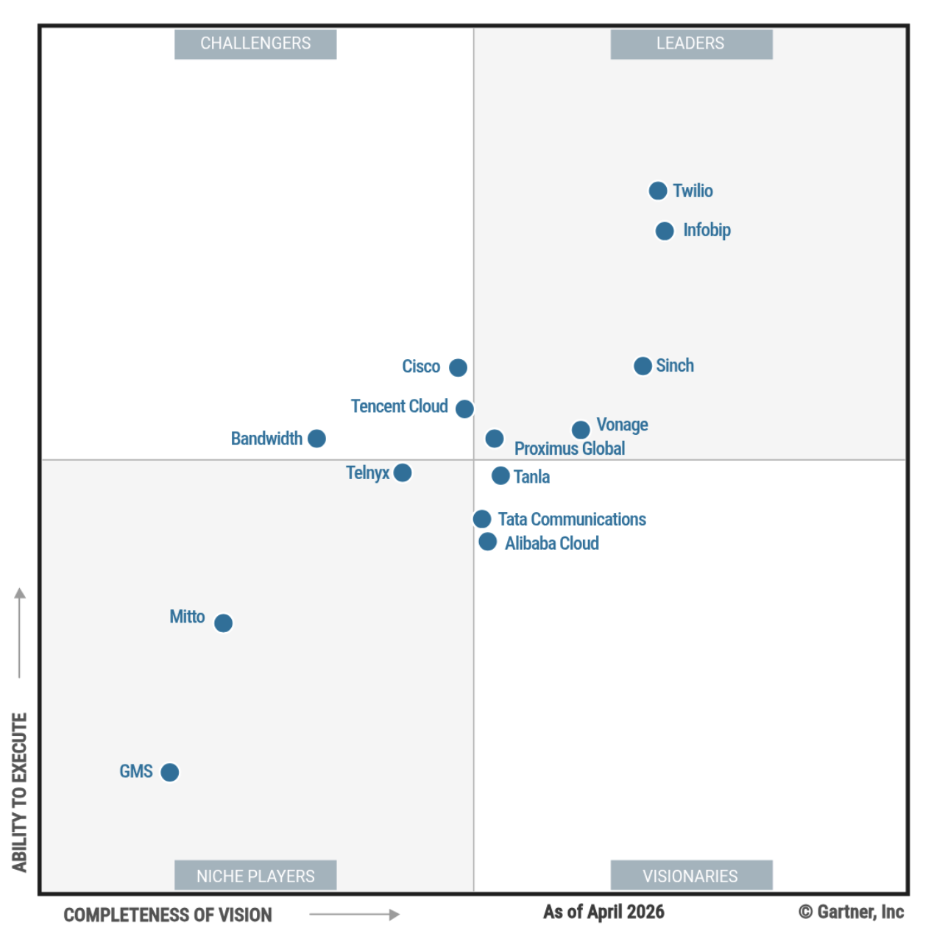
Source: Gartner Magic Quadrant for Communications Platform as a Service, May 2026

In Gartner's assessment, push notifications are an optional capability for this market, not a required one. This is why push support differs so much between the Leaders, as the table below shows. Quadrant position is therefore a starting point for this assessment, not a measure of fit.

 | Push | SMS | Email
Twilio | Beta | + | +
Infobip | Generally available | + | +
Sinch | Beta | + | +
Vonage | None | + | Beta
Proximus Global | None | + | +

Vonage and Proximus Global provide no push channel. Push is a required channel (G-02), so neither is described further.
All five also offer WhatsApp and RCS, which are not required today.
Because push is optional for this market, one vendor outside the Leaders quadrant, Cisco Webex Connect, was also assessed (3.6).

What each engine provides

 | Twilio | Infobip | Sinch
Push maturity | Beta – outside the SLA and support terms | Generally available | Beta
Push without a vendor library in the app | Yes – device tokens are passed in each request | No – the app must register through Infobip's library | No – the app must register through Sinch's library
Products behind push, SMS and email | Three: Messaging, SendGrid, Communications API | One | Two: Conversation API, Mailgun
Channel fallback | SMS, RCS and WhatsApp only | Push, SMS and email, in one request | Push and SMS
Send-time windows | US rules only | SMS, push and email | Email only
Published availability commitment | 99.95% (99.99% enterprise), excluding push | None | 99.95%, best effort; Mailgun 99.99%
Duplicate-send protection on the standard send API | None | None | None
Message history available | 13 months (SMS) | 48 hours by API, 3 months in the web interface | Configurable; none stored by default for one-way messages
Data location | Ireland (SMS), EU (email) | Great Britain (push, SMS), EU (SMS, email) | EU (SMS, email)
Marketing Cloud connector | None from Twilio | SMS and messaging apps – not push or email | SMS and messaging apps. Push not documented; email not included (separate product)
Authentication | OAuth 2.0 client credentials or API key; SendGrid uses API keys | OAuth 2.0 client credentials or API key | OAuth 2.0 client credentials
Integration | Public HTTPS API for every channel. Client libraries (SDKs) available as an option | Public HTTPS API for every channel. Client libraries (SDKs) available as an option | Public HTTPS API for every channel. Client libraries (SDKs) available as an option

Engine highlights

Twilio
Twilio provides each channel as a separate service. The services relevant to operational notifications:
Service | What it is for | Status
Messaging | SMS, WhatsApp and RCS: sending, delivery status, STOP opt-outs | Generally available
SendGrid | Email: sending, templates, delivery and bounce events, unsubscribes | Generally available
Push Notifications API | Push to iOS and Android apps through FCM and APNs, using existing device tokens | Private beta
Communications API | One API for SMS, WhatsApp, RCS, email and push, with fallback between SMS, RCS and WhatsApp. The Push Notifications API is part of it | Private beta
Other Twilio services that send push are not suitable: Notify is no longer supported, Conversations sends push only for chat events, and Verify Push is for login approval.

Key Highlights
- The only engine whose push API accepts device tokens directly: "You can send a notification directly without storing it as a registration" (documentation).
- That API is part of the Communications API, which "is currently available as a Private Beta product". Private beta products "are not covered by the Twilio Support Terms or Twilio Service Level Agreement". Twilio announced the push API in May 2026 as the replacement for Twilio Notify, which is no longer supported. No general-release date is published.
- SMS, WhatsApp and RCS run on Messaging; email on SendGrid. Nothing falls back between push, SMS and email.
- A published service level agreement with service credits, which excludes beta products.
- SMS is processed and stored in Ireland. EU email residency through SendGrid needs a higher plan. There is no UK region.

Infobip
Infobip provides its channel services through one set of APIs, with products on top that combine channels. The services relevant to operational notifications:
Service | What it is for | Status
SMS API | SMS: sending, delivery status, STOP opt-outs, delivery time windows | Generally available
Email API | Email: sending, templates, delivery and bounce events, unsubscribes, delivery time windows | Generally available
Mobile Push | Push to iOS and Android apps. Requires Infobip's mobile library in the app | Generally available; only as part of a SaaS product:  - Moments (customer communication flows, segmentation and automation)  - Conversations (contact centre)  - Answers (chatbots).
OMNI failover API | One request across push, SMS and email, falling back to the next channel if one fails | Available
Messages API | One API for SMS, WhatsApp, RCS and other messaging apps, with fallback. Push and email are not included | Generally available
People | Customer profiles linking a person to phone number, email address and app installation | Generally available

Key Highlights
- The only Leader with push generally available, and the only one where push, SMS and email are one product. They fall back in a single request through the failover API or through flows.
- Push requires Infobip's mobile library. The push send API addresses a device through a registration made by that library. It has no field for a device token, and no import of existing tokens is documented.
- Infobip publishes guidance for running alongside another push provider, but for iOS says: "We don't recommend having multiple push notification providers functioning within the same application."
- Push is sold only within Infobip's customer engagement package, charged per engaged customer per month plus per message. It is not available on its own.
- Delivery time windows hold SMS, push and email outside permitted days and hours. The window is set in UTC, so UK summer time must be allowed for.
- No published availability commitment.

Sinch
Sinch provides messaging channels through one API and email through a separate product, Mailgun. The services relevant to operational notifications:
Service | What it is for | Status
SMS API | SMS only: sending and delivery status. An alternative to the Conversation API when only SMS is needed | Generally available
Conversation API | One API for SMS, RCS, WhatsApp, push and other messaging apps, with fallback between channels. Email is not included | Generally available; push in closed beta
Sinch Push | Push to iOS and Android apps, as a channel of the Conversation API. Requires Sinch's mobile library in the app | Closed beta
Mailgun | Email: sending, templates, delivery and bounce events, unsubscribes, scheduled delivery | Generally available

Key Highlights
- Push is currently available for closed beta testing. No general-release date is published.
- Sinch Push is built on Sinch's chat library and uses chat message types (text, card, carousel, choice). The documentation does not show whether it can display a standard notification that opens a specific screen in the app.
- SMS and push share the Conversation API and can fall back to one another. Email is on Mailgun, a separate product that cannot join that fallback.
- The clearest documentation in the field on delivery callbacks, retry behavior and throughput limits.
- A published messaging service level of 99.95%, on a "reasonable endeavors" basis. Mailgun commits to 99.99% with service credits.
- A Marketing Cloud connector listed on AppExchange.
- UK customers contract with Sinch Sweden AB.

Measured against requirements
Requirement | Twilio | Infobip | Sinch
Push, SMS and email (G-02) | ! push in private beta | ! push generally available; only as part of a SaaS product | ✕ push in closed beta
Channel choice and fallback in the engine (G-03) | ✕ SMS, RCS and WhatsApp only | ✓ one request, OMNI failover | ! push and SMS; email outside
Marketing Cloud connector (comparison point, not a requirement) | ✕ none from Twilio | ! SMS and messaging apps – not push or email | ! SMS and messaging apps; push not documented; email not included
99.9% availability, contracted (N-03) | ! 99.95% published – push excluded | ! nothing published – negotiate | ! 99.95%, best-effort basis
No duplicates visible to the customer (N-04) | ✕ not provided | ✕ not provided | ✕ not provided
UK or EU processing (N-06) | ✓ EU – no UK region | ✓ UK for push and SMS; EU for email | ✓ EU only
✓ Meets the requirement ! Meets it with a condition ✕ Does not meet it

Twilio
Strengths
- Push accepts device tokens directly, with no vendor library in the app, so the device token can be held in the Notification Service.
- A published availability commitment with service credits (99.95%, or 99.99% on enterprise tiers).

Limitations
- Push is in private beta and is not covered by Twilio's support terms or availability commitment.
- Push, SMS and email sit on three separate products, each with its own API and credentials.
- No fallback between push, SMS and email (G-03).
- No UK processing. SMS is processed in Ireland, and email in the EU on the higher plans only.

Outcome
Meets the requirements, provided push reaches general release with a commitment before go-live.

Infobip
Strengths
- Push is generally available.
- One engine. Push, SMS and email can fall back from one to another in a single request, through the OMNI failover API (G-03).
- Delivery time windows on SMS, push and email.
- Push and SMS processed in Great Britain.
- A Marketing Cloud connector for SMS and messaging apps.

Limitations
- Push is available only as part of one of Infobip's SaaS products (CN-04): Moments, Conversations or Answers. Each carries a monthly fee on top of per-message charges. Using push therefore means paying for capabilities that this solution does not need. Moments, the product meant for customer communication, also overlaps with SFMC.
- Push requires Infobip's library in the Jewson mobile app.
- No published availability commitment (N-03).
- Push and email are processed in different locations: push in Great Britain, email in the EU.
- No published price for push.

Outcome
Meets the requirements. Selling push only as part of a SaaS product is a significant commercial risk unless push can be contracted as a separate delivery channel.

Sinch
Strengths
- Push and SMS fall back to one another in a single request.
- A published service level for messaging (99.95%, best effort), and 99.99% with service credits for email.
- The clearest documentation in the field on delivery callbacks, retry behavior and throughput limits.
- A Marketing Cloud connector for SMS and messaging apps.

Limitations
- Push is in closed beta, with no general-release date.
- Push requires Sinch's library in the Jewson mobile app, and the library takes over the app's push handling (CN-02, CN-03).
- Email sits on a separate product and cannot join the push and SMS fallback (G-03).
- No UK processing; EU only.
- No published price for push.

Outcome
Does not meet the requirement today, because push is in closed beta.

Summary
Among the Leaders, Twilio and Infobip both meet the requirements, each with a significant limitation. Sinch does not meet them today.
Twilio is the only engine that can send push using device tokens the app obtains directly from APN and FCM, without a vendor library in the app. Its SMS and email are mature, generally available products with a published availability commitment. Its main weakness is push itself – the push API is in private beta with no general-release date available.
Infobip is the only Leader whose push is not in beta, and the only engine that can fall back across push, SMS and email in a single request. Its main weakness is commercial, push is sold only as part of one of Infobip's SaaS products (Moments, Conversations or Answers), so using it means paying for capabilities this solution does not need (CN-04). Push also requires Infobip's library in the Jewson app (CN-02, CN-03), and Infobip publishes no availability commitment.
Sinch has the clearest technical documentation of the three, a published service level, and fallback between push and SMS. Its push, however, is in closed beta with no general-release date. Email sits on a separate product outside the fallback.
In short, neither Twilio nor Infobip offers push without a significant condition: Twilio's is still in beta, and Infobip's comes only with a SaaS product.
Because no Leader offers push without a significant condition, the field was extended one step beyond the Leaders (3.6). The verdict and next steps follow in 3.7, and an alternative option in 3.8.

Extra step – Cisco Webex Connect
Push is an optional capability in Gartner's definition of CPaaS (3.2), so the field was extended one quadrant beyond the Leaders. Cisco moved from Visionary to Challenger in the May 2026 Magic Quadrant and is the strongest fit outside the Leaders. The other vendors outside the Leaders quadrant were screened but not assessed in depth.
Cisco Webex Connect provides all channels on one engine, with a visual flow builder that combines them. The services relevant to operational notifications:
Service | What it is for | Status
Mobile push | Push to iOS and Android apps through the Push node in flows. Requires the Webex Connect SDK in the app | Generally available
SMS | SMS: sending and delivery status | Generally available
Email | Email through the Email node, sent via AWS SES or SMTP | Generally available
Flow Builder | Visual flows that combine channels and branch to another channel on error or timeout | Generally available

Key Highlights
- Push is generally available, but reaches only apps that have the Webex Connect SDK integrated. As with Infobip, a vendor library is needed in the Jewson app (CN-02, CN-03).
- Push, SMS and email are on one engine. Flows can branch to another channel when a send fails or times out; which push failure signals reach the flow needs confirming with Cisco.
- Tenants can be hosted in AWS London, so message content and contact details can be processed in the UK (N-06).
- Availability is contractual and tiered. The Standard SLA is 99.5%, below N-03; the Gold SLA is 99.95%, with a 15-minute response to priority-1 incidents.
- Email is sent through AWS SES or SMTP; which route Cisco provides needs confirming.
- Licensed by edition through Cisco, with usage entitlements and overage fees. No public per-message price.
- No Salesforce Marketing Cloud connector. Cisco's Salesforce app extends Sales, Service and Commerce Cloud and Field Service, not Marketing Cloud.

Source: Cisco Webex Connect documentation and offer description, October 2026; Gartner Magic Quadrant for CPaaS, May 2026.

Measured against requirements
Requirement | Cisco Webex Connect
Push, SMS and email (G-02) | ✓ push generally available; SMS and email on the same engine
Channel choice and fallback in the engine (G-03) | ! built in flows that branch on error or timeout – confirm push failure signals
Marketing Cloud connector (comparison point, not a requirement) | ✕ none
99.9% availability, contracted (N-03) | ✓ Gold SLA 99.95%, 15-minute P1 response (Standard is 99.5%)
No duplicates visible to the customer (N-04) | ! not documented – confirm with Cisco
UK or EU processing (N-06) | ✓ UK tenant, hosted in AWS London
✓ Meets the requirement ! Meets it with a condition ✕ Does not meet it
Strengths
- Push, SMS and email generally available on one engine.
- UK hosting: tenants can run in AWS London.
- Contracted availability of 99.95% on the Gold SLA, with a 15-minute priority-1 response.
- Fallback orchestrated inside the engine, in visual flows.

Limitations
- Push requires the Webex Connect SDK in the Jewson mobile app – the same issue as Infobip (CN-02, CN-03).
- No Salesforce Marketing Cloud connector.
- Licensed by edition through Cisco, with usage entitlements and overage.
- Email route (AWS SES or SMTP) and duplicate protection to be confirmed with Cisco.

Outcome
Meets the requirements, with one caveat: there is no Salesforce Marketing Cloud connector, so SFMC cannot use Cisco Webex Connect for additional channels without a custom integration.

Verdict and next steps
Three engines meet the requirements, each with one caveat.
Engine | Gartner position | The caveat
Twilio | Leader | Push notifications are available only in beta (private beta, outside Twilio's support terms and availability commitment).
Infobip | Leader | Push is part of another Infobip SaaS product and must be purchased with it; it cannot be contracted as a standalone channel.
Cisco Webex Connect | Challenger | No Salesforce Marketing Cloud connector.
Sinch does not meet the requirements today, because its push is in closed beta.
Proposed next steps
- Contact the three vendors – Twilio, Infobip and Cisco – to set up working sessions.
- Run three working sessions – to settle each caveat and the open points: Twilio's general-release date and availability commitment for push; whether Infobip will contract push as a standalone channel; Cisco's edition, Gold SLA, email route and push failure signals; and, for all three, 99.9% in contract (N-03), duplicate protection (N-04) and data processing terms (CN-07).
- Price and prove one engine – price the preferred engine against expected volumes, including the monthly statement peak (N-05), and prove one urgent notification end to end against N-01.

Alternative option – select an engine, build bespoke push
If push from a CPaaS stays in beta or bundled, the channels can be split. A commercial off-the-shelf (COTS) notification engine is bought for SMS and email – and, later, social and messaging apps – while push is built as a bespoke service that sends directly through Apple Push Notification service (APNs) and Firebase Cloud Messaging (FCM). Both sit behind the Notification Service, which decides recipient, content and channel for every notification.
Component | Approach | Note
Push notifications | Set up – bespoke, direct to APNs and FCM | The app hands its device token to the Notification Service. No vendor library in the app.
SMS, email, social and messaging apps | Buy – a COTS notification engine | Chosen for SMS and email only, so push maturity and push bundles no longer drive the choice.

Strengths
- The best of both: fast bespoke push notifications, and a leading notification engine for SMS and email.
- Freedom to select the most suitable and affordable COTS engine – for example Infobip's SMS and email without its push bundle, or Twilio's Messaging and SendGrid without the beta push.
- No vendor library in the Jewson app; device tokens stay with the Notification Service (avoids CN-02, CN-03).

Limitations
- Bespoke push needs effort to implement and ongoing support.
- Fallback between push, SMS and email, and duplicate prevention, are no longer handled inside one engine; the Notification Service handles them (G-03, N-04).
- Apple and Google give no delivery commitment, so push fallback can react only to failures they report, unless the app confirms receipt.

On Azure. Bespoke push can run in STARK UK's own Azure tenant, for example on Azure Notification Hubs, which accepts device tokens directly and carries a 99.9% availability commitment. Azure Communication Services should not be used for SMS or email: Microsoft is retiring its SMS and email services on 30 September 2028, and new customers cannot sign up from 23 October 2026.

Integration with the Existing Landscape

Where the engine sits
The notification engine delivers messages over push, SMS and email, and reports what happened to each one. It does not detect business events and does not decide who to tell; the new Notification Service does (C-01). In the diagram, black boxes are new components and grey boxes are existing ones.

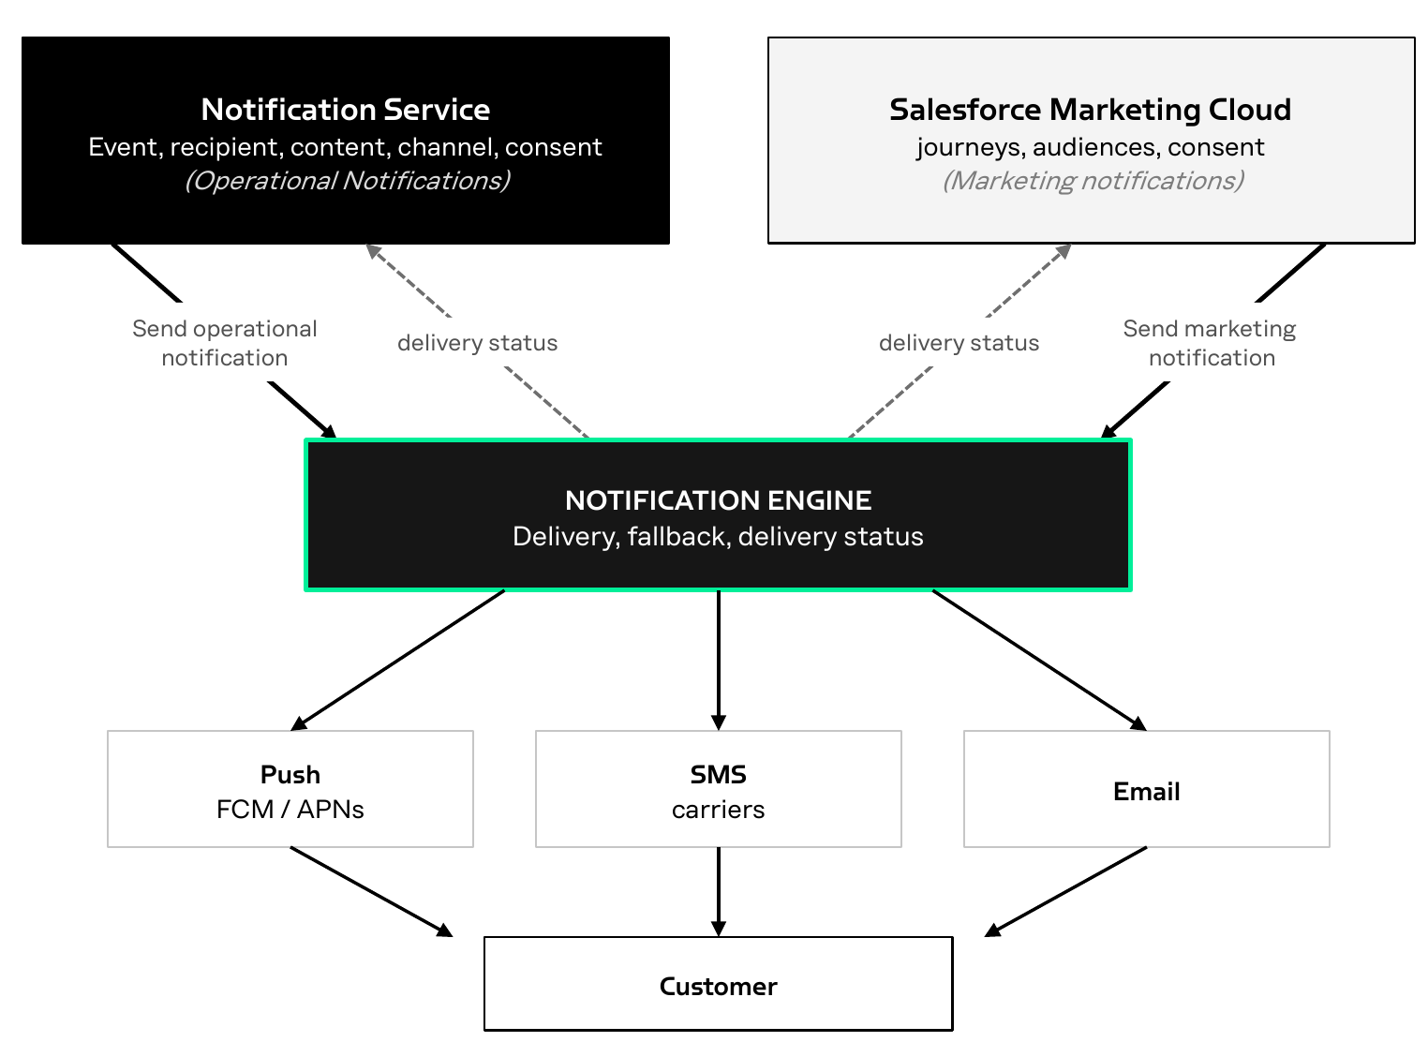

System | Role in notifications
Notification Service (new) | Detects the event from the source systems and decides recipient, content, channel and consent. Calls the engine for operational notifications.
Salesforce Marketing Cloud (SFMC, existing) | Marketing's tool for segments, journeys, content and timing (C-02).
Notification engine (new) | Delivers on every channel, handles carrier connections and sender registration, and reports delivery.
Jewson mobile app | Receives push through Firebase Cloud Messaging and Apple Push Notification service.
How an operational notification flows
- The Notification Service detects a business event, such as an order ready to collect or an account restricted.
- The Notification Service determines who to notify, with which content and on which channel, and calls the engine's API.
- The engine delivers the message and, where configured, falls back to another channel if delivery fails.
- The engine reports delivery status back to the caller.

Salesforce Marketing Cloud
Marketing campaigns, audiences and content stay in SFMC (C-02). Operational notifications are sent by the Notification Service directly, not through SFMC, so that no one system becomes a dependency for the others (G-05).
SFMC can also use the engine to extend Marketing's channels:
- SMS and messaging apps. Infobip and Sinch provide connectors that add SMS, WhatsApp, RCS and other messaging apps as steps in SFMC journeys, with delivery status returned to SFMC. Twilio and Cisco Webex Connect provide no connector.
- Push and email. No connector covers them. SFMC keeps its own push (MobilePush) and email unless a custom integration is built.
- One app, two push libraries. If the chosen engine needs its own library in the Jewson app, and Marketing keeps MobilePush, the app would contain two push libraries, which Salesforce does not recommend (CN-02).

Concerns
Risks and uncertainties that may affect delivery.
ID | Rating | Concern | Impact
CN-01 | High | Push is the least mature channel among the CPaaS Leaders. Of the five Leaders, only Infobip offers push as a generally available product. Twilio's push is in private beta, Sinch's is in closed beta, and Vonage and Proximus Global have none. Outside the Leaders, Cisco Webex Connect also offers it generally available; like Infobip, it needs its own library in the app. | The channel that started this project has the fewest options. A beta push product may change or be delayed before go-live.
CN-02 | High | Two push libraries in one mobile app. Infobip, Cisco Webex Connect and Sinch each need their own library in the app. If MobilePush is also added for Marketing, the app contains two push libraries, which Salesforce states "is not recommended… results are not guaranteed." | Risk of lost device registrations, and of duplicate or missing notifications. The risk is avoidable: MobilePush is not yet integrated into the app.
CN-03 | High | Push registrations that must later be migrated. If the MobilePush library is added to the app before the engine is chosen, and the chosen engine needs its own library, every device must register again. Only devices that update and reopen the app will do so. | Push reach is lost for devices that do not update, and the loss cannot be measured. None of the Leaders that need their own library documents an import of existing registrations; for Cisco Webex Connect this is to be confirmed.
CN-04 | High | Infobip sells push only as part of one of its SaaS products: Moments (customer communication flows), Conversations (contact centre) or Answers (chatbots). Push is not available as a separate delivery channel. Each product carries a monthly fee, plus per-message charges. | Capabilities that the solution does not need would be paid for. Moments, the product meant for customer communication, also overlaps with SFMC. A package fee that is not tied to the messages sent is hard to relate to the value of operational notifications. A second engagement platform also creates pressure to use it, which weakens the boundaries set by C-01 and C-02.
CN-05 | High | Among the Leaders, no engine publishes an availability commitment that meets N-03 for all three channels. Twilio publishes 99.95% but excludes push while it is in beta. Sinch publishes 99.95% for messaging on a "reasonable endeavors" basis. Infobip publishes no availability commitment. Cisco Webex Connect commits to 99.95% on its Gold SLA; its Standard SLA (99.5%) does not meet N-03. | For the Leaders, the contracted 99.9% (N-03) cannot be shown from published terms; it depends on negotiation. For Cisco Webex Connect, it depends on buying the Gold tier.
CN-06 | High | No Leader documents protection against duplicate sends on its standard send API; for Cisco Webex Connect this is to be confirmed. Duplicates can come from a retry after a timeout, an event read twice, or a scheduled run repeated. | A duplicate "your payment is overdue" damages trust. A duplicate or contradictory "account restricted" can stop a customer ordering.
CN-07 | High | Customer financial data passes to a third-party processor. Balances, credit-limit proximity and overdue status are message content, such as "Your current balance is £X". That content passes to the engine and on to mobile networks and email providers. No position is recorded on what may cross that boundary, on data processing terms, on sub-processors, or on how long the engine may keep message content. | A data protection review is likely to raise this before any contract is signed.
CN-08 | High | A trade account is a business, not a person. The account holder who manages the finances is usually not the site staff who place and collect orders. The fifteen notifications mix both audiences: balances, credit limits and overdue payments alongside order and collection messages. | If notifications go to every registered user of an account, a site worker collecting materials receives the company's credit limit and overdue balance. That is a commercially sensitive disclosure inside the customer's own business.
CN-09 | Medium | The line between operational and marketing messages is not agreed. Abandoned-basket and other re-engagement prompts are treated as marketing (X-01), but there is no agreed rule for messages that fall between the two. | Either scope grows into SFMC's area, or a gap is left with no owner.
CN-10 | High | The work outside the engine is larger than the work inside it. Event detection, scheduling, recipient resolution, consent checks, send-time rules, duplicate prevention, keeping each notification until the engine accepts it, message ordering and expiry, the return path for delivery receipts and STOP replies, and audit all sit outside the engine, in the Notification Service (section 4). | If a per-message price is read as the project cost, the budget will be short by the larger part.
CN-11 | Medium | Operational messages are not visible in SFMC. They are sent directly to the engine, so SFMC holds no record of them, and push sent through the engine does not appear in MobilePush reporting. Operational and marketing messages reach the same customers from two systems. | There is no single view of what a customer has received. Contact frequency and tone across operational and marketing messages are not coordinated.

